Accessing Microsoft Teams from a computer
*You may also download the Microsoft Teams app on your tablet or phone. The screens will look different but the overall experience is the same.*

- From the Warren Consolidated Schools website (www.wcskids.net), hover over “Parents/Students”. Then, click on “Student Email Login”.
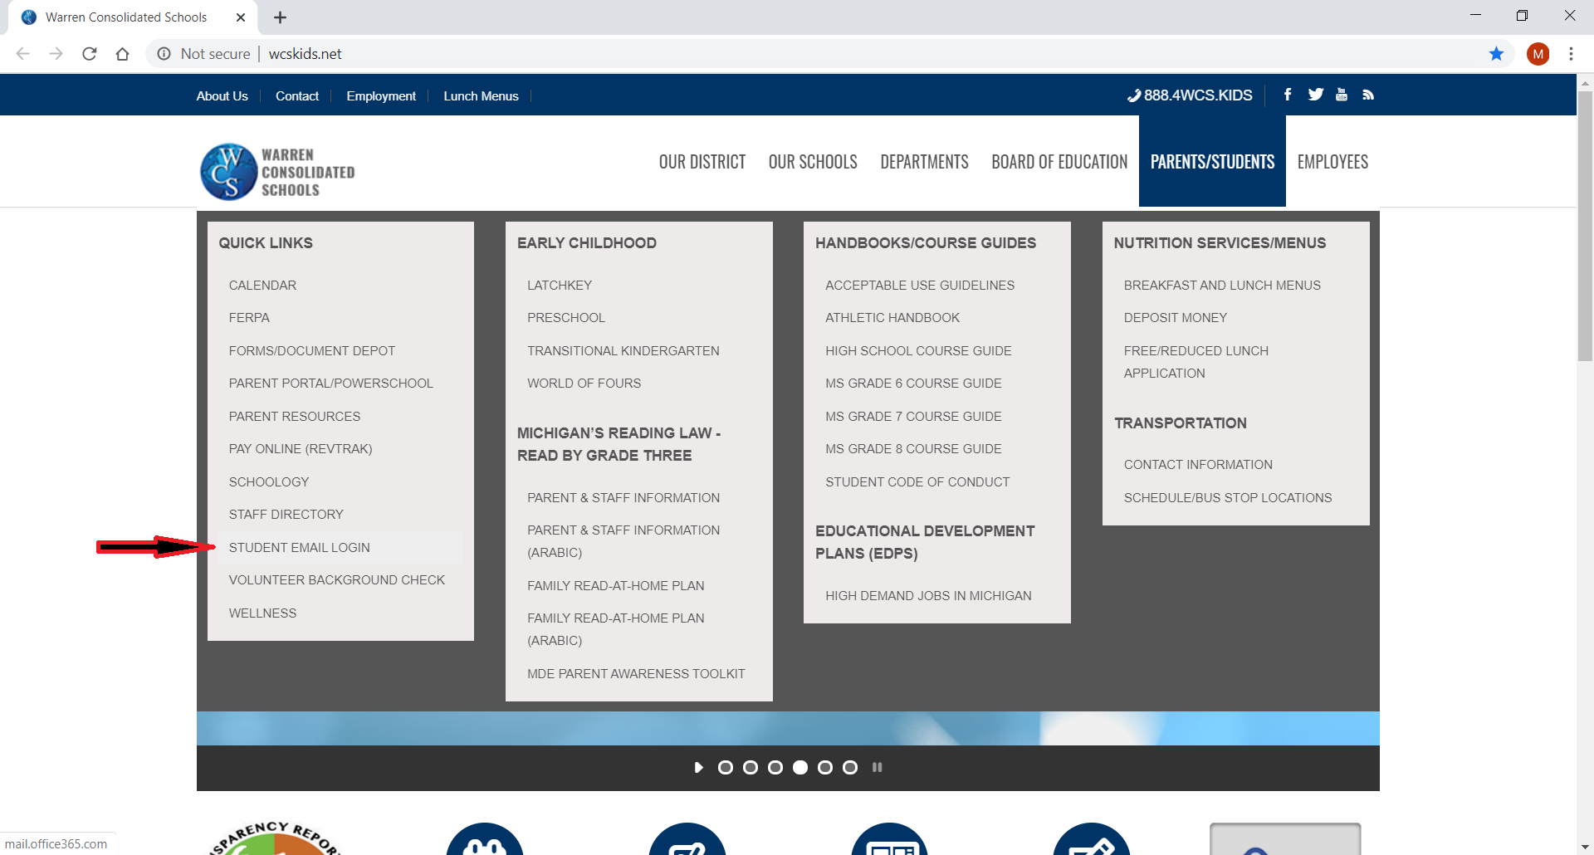

- If you’ve used your school email before, it will probably show up (as mine is, below) for you to select. If not, click on “Use another account”.
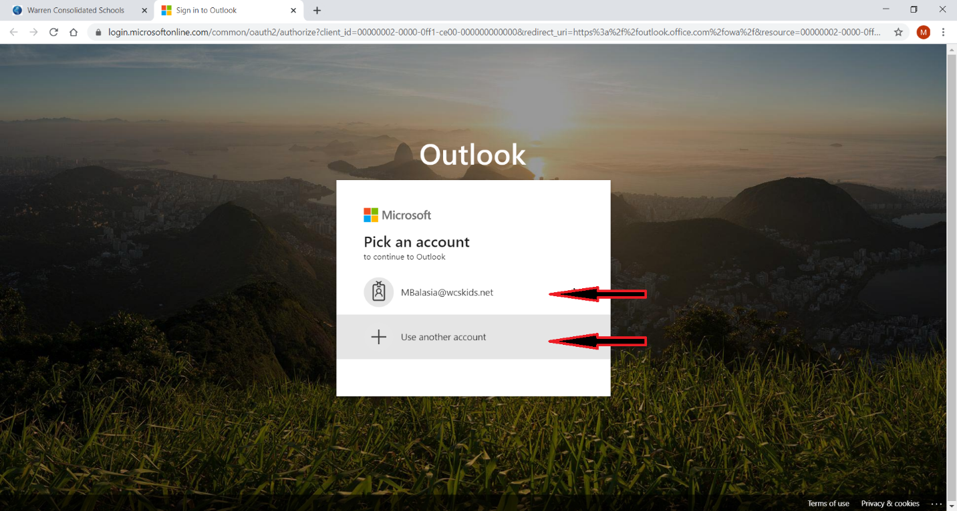
OR

- Enter your school email: studentnumber@wcskids.net (your student number is a 6-digit number, starting with an 8). If you don’t know yours, email me mbalasia@wcskids.net and I will do my best to find it for you.
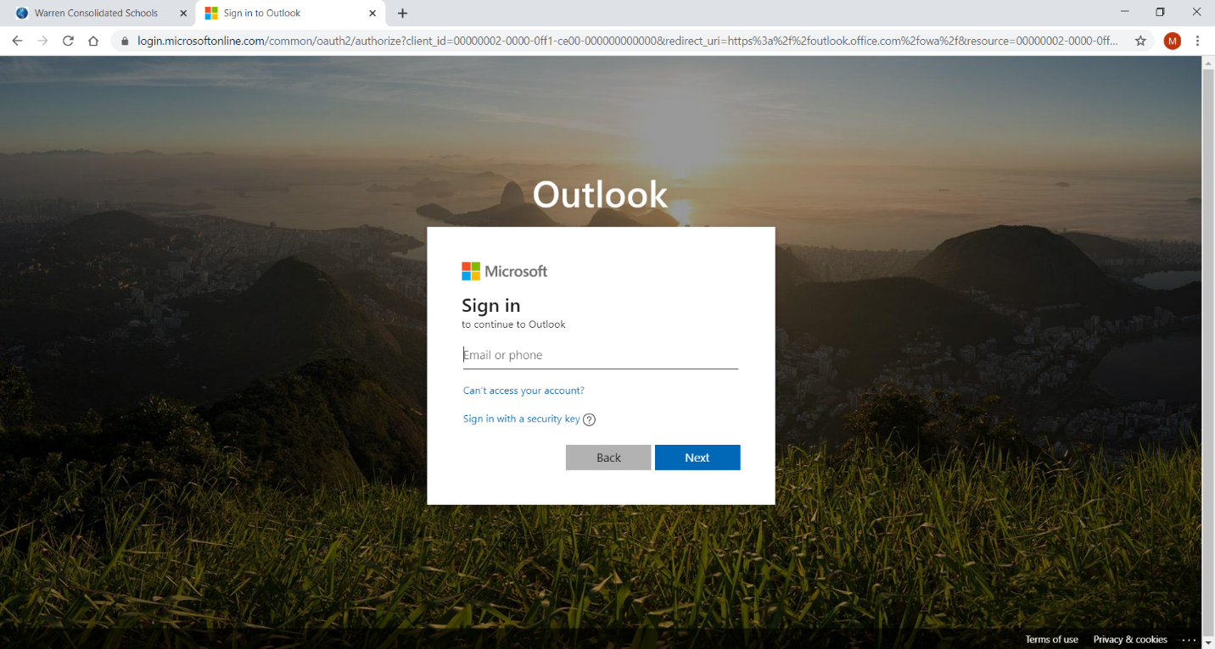

- Enter your password: the same password you use to log into the computers at school. If you don’t know yours, email me mbalasia@wcskids.net and I will do my best to find it for you.
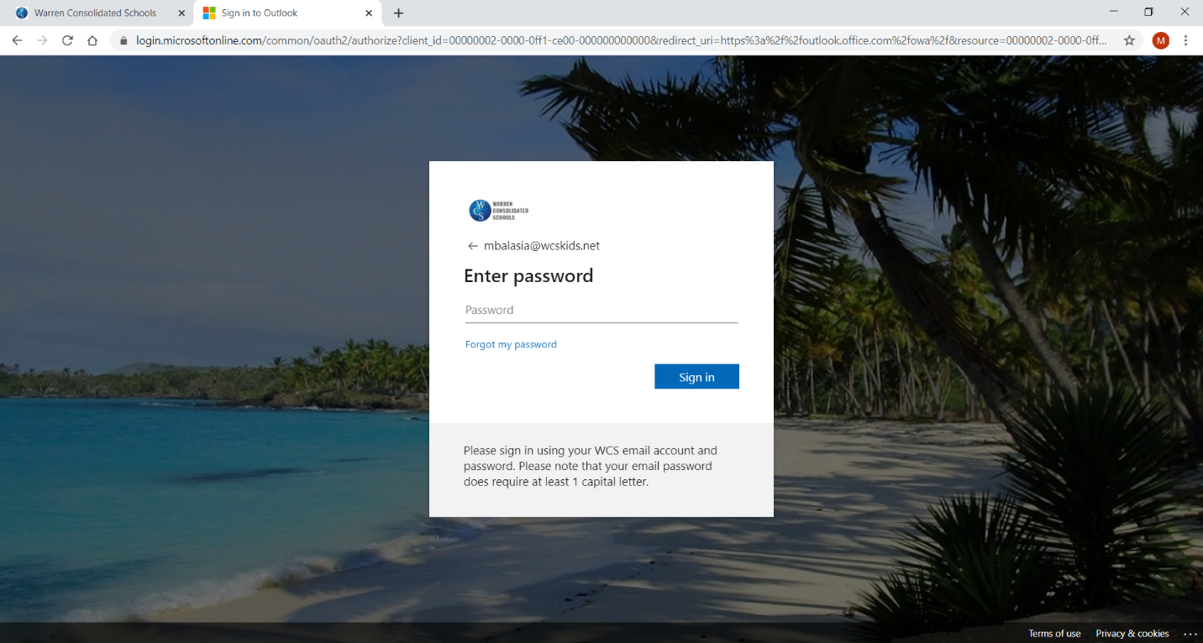

- Click on the “Waffle” (located in the upper, left-hand corner).
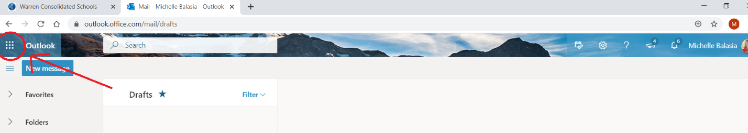

- From the list of Apps, click on “Teams”.
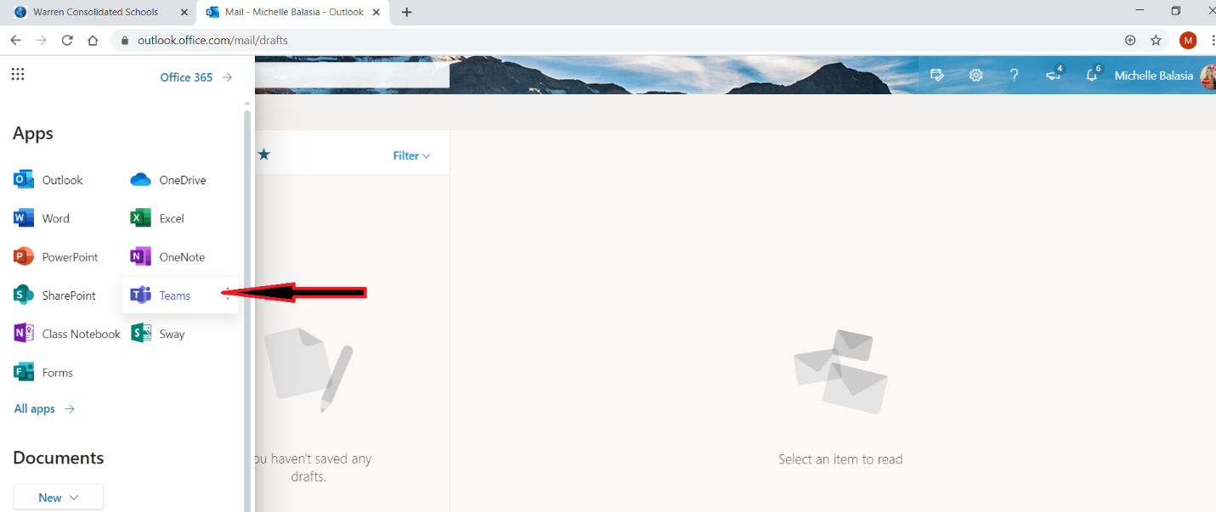

- I have already added you to the I.M. Algebra 1 Team. Click on it.
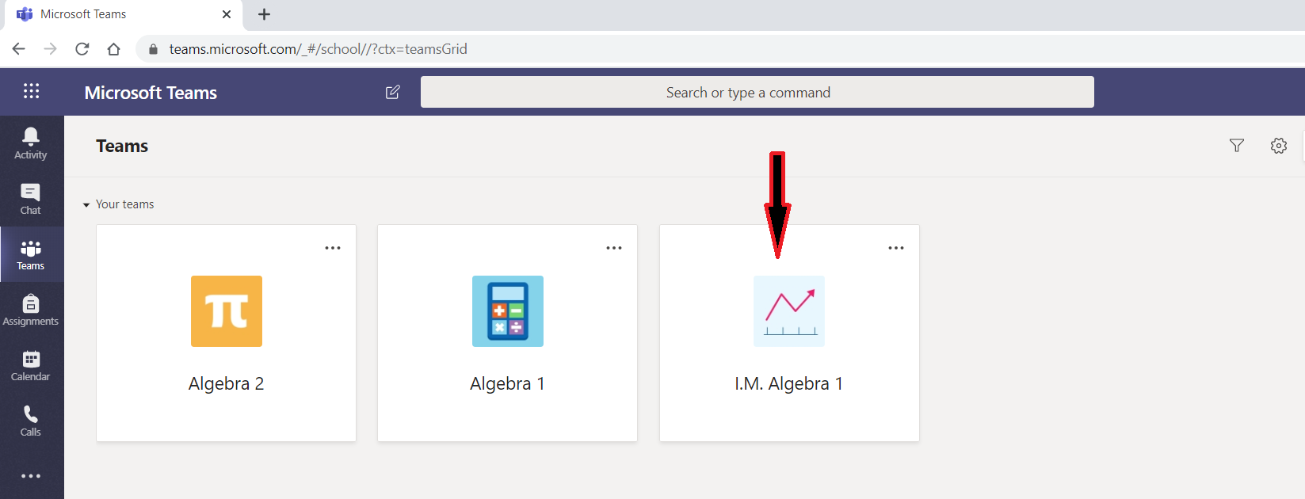

- Click on “Enrichment Work”.
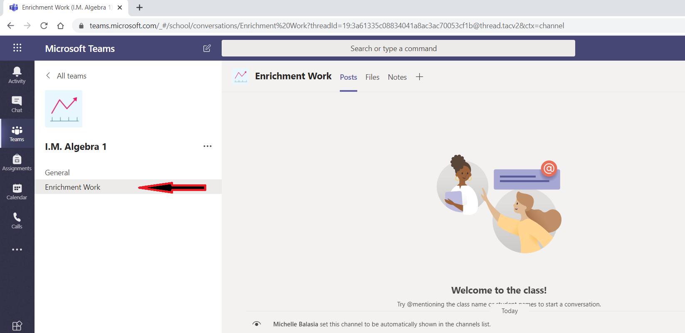

- A few simple tasks will be added through the week, including an invite to our online Q & A Session!

